Treasury Management - Workflow Functional Document

Application: | NGERP-CENTRA
WorkFlow: | Procure To Pay
WorkFlow Item Name: | Treasury Receipt

Description
Treasury Receipt refers to the Process of Financial Cash flow Process of Bank.

Work Flow Process:

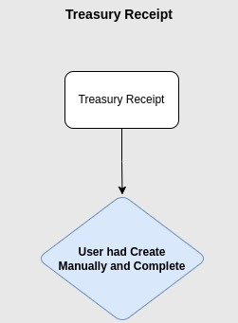

Business Rules:

- This transaction will be done only in HQOW
- There are 3 Document types in Treasury Receipt for manual creation
- Bank Loan
- Shareholder Borrowing
- Shareholder Loan

- Bank Loan :

A bank loan is a financial product where a bank or financial institution lends money to an individual, business, or organization with the expectation that it will be paid back, typically with interest, over a set period. Bank loans can be used for various purposes, such as buying a home, funding a business expansion, or covering personal expenses.

- Shareholder Borrowing :
Shareholder borrowing refers to a situation where a company’s shareholder borrows money from the company. This is essentially the reverse of a shareholder loan, where the shareholder lends money to the company. In shareholder borrowing, the company acts as the lender, and the shareholder is the borrower.

- Shareholder Loan :
A shareholder loan refers to a loan made by a shareholder (or an owner) of a company to the company itself. This type of loan is typically used when the company needs financing but doesn't want to, or cannot, secure funding from traditional lenders or banks.

